# ParkLife Report – Data Dashboard

Version 0.1A

Our original vision for a ParkLife Dashboard is summarised in the following infographic design.

This combines a variety of measurements from multiple data sources across different features of park centric activity from people and nature into a single heatmap style display for an hour by hour view of a single day.

This form of infographic display is intended to make it easier to understand park behaviour and answer questions such as: when is the park busiest, who is making most use of the park, how influential is the weather on park use, do events or maintenance work on the park impact park users, is there a pattern to park use, and is this day a particularly busy or quiet day?

Accessing existing sources of data proved to be difficult during the course of the project due to both fundamental availability and data sharing constraints on behalf of the data owners. Our approach therefore was refocused to investigate how we could utilise direct sensing within the parks to capture data for a Park Dashboard that most importantly was not privacy invasive and would have broad applicability to all parks and greenspaces.

It should be recognised that our urban parks are typically large open areas without defined gated entry and exit points. In this case, the sensors we deploy in a park create a partial picture since they can only provide a measurement for the area around them within sensor range. It is therefore only possible to be representative in measuring activity rather than entirely precise; we cannot count exactly how many people are in a park at a moment in time for example, without perhaps deploying prohibitively expensive and privacy invasive sensing – it is not a venue where people hold a ticket or token to enter and pass through.

However, we can combine these different sensor measurements to create a more complete view and a comparable measure over time for the park. This type of analysis will be unique to each park and therefore will not generate directly comparable values across different parks, but will enable relative measures as patterns of behavior to be compared across parks.

Whilst we considered many different sensing options, the sensing we focused on for implementation in this project covered three main aspects:

* Pathway presence counting – using infra-red based distance ranging LiDAR, which enables precise detection of people (and bicycles) passing within the bounds of a close by pathway.
* Gate openings in children’s fenced play areas – using a simple magnetic switch that is activated whenever a gate is opened and closed. By measuring the rate of gate openings over a set period we can infer how busy the corresponding family play area is.
* Detection of bats – using ultrasonic microphones, which provides a strong indicator of healthy biodiversity, since bats require an abundance of insect life, which in turn need healthy flora. Ultrasonic sound is above the range of human hearing (>20KHz) and helpfully this simplifies the deployment of the microphone into a public area, since we can demonstrate we are not storing or processing the lower frequency sound range of the human voice.

We provide examples of the data we were able to capture during the project from these different sensors in the following.

Meadows Park – Presence Count Heatmap (over 1 week)

The Meadows is a large park to the south of the city separating the University of Edinburgh central campus from local student accommodation. From the above heatmap it is clear that the Meadows pathway being monitored is most active during office hours between roughly 7am and 7pm, with peak times at 9am and 6pm which would match with people on their way to and from work and study, whilst maintaining a fairly consistent flow throughout the day between these peak times.

Inverleith Park – Presence Count Heatmap (over 2 weeks)

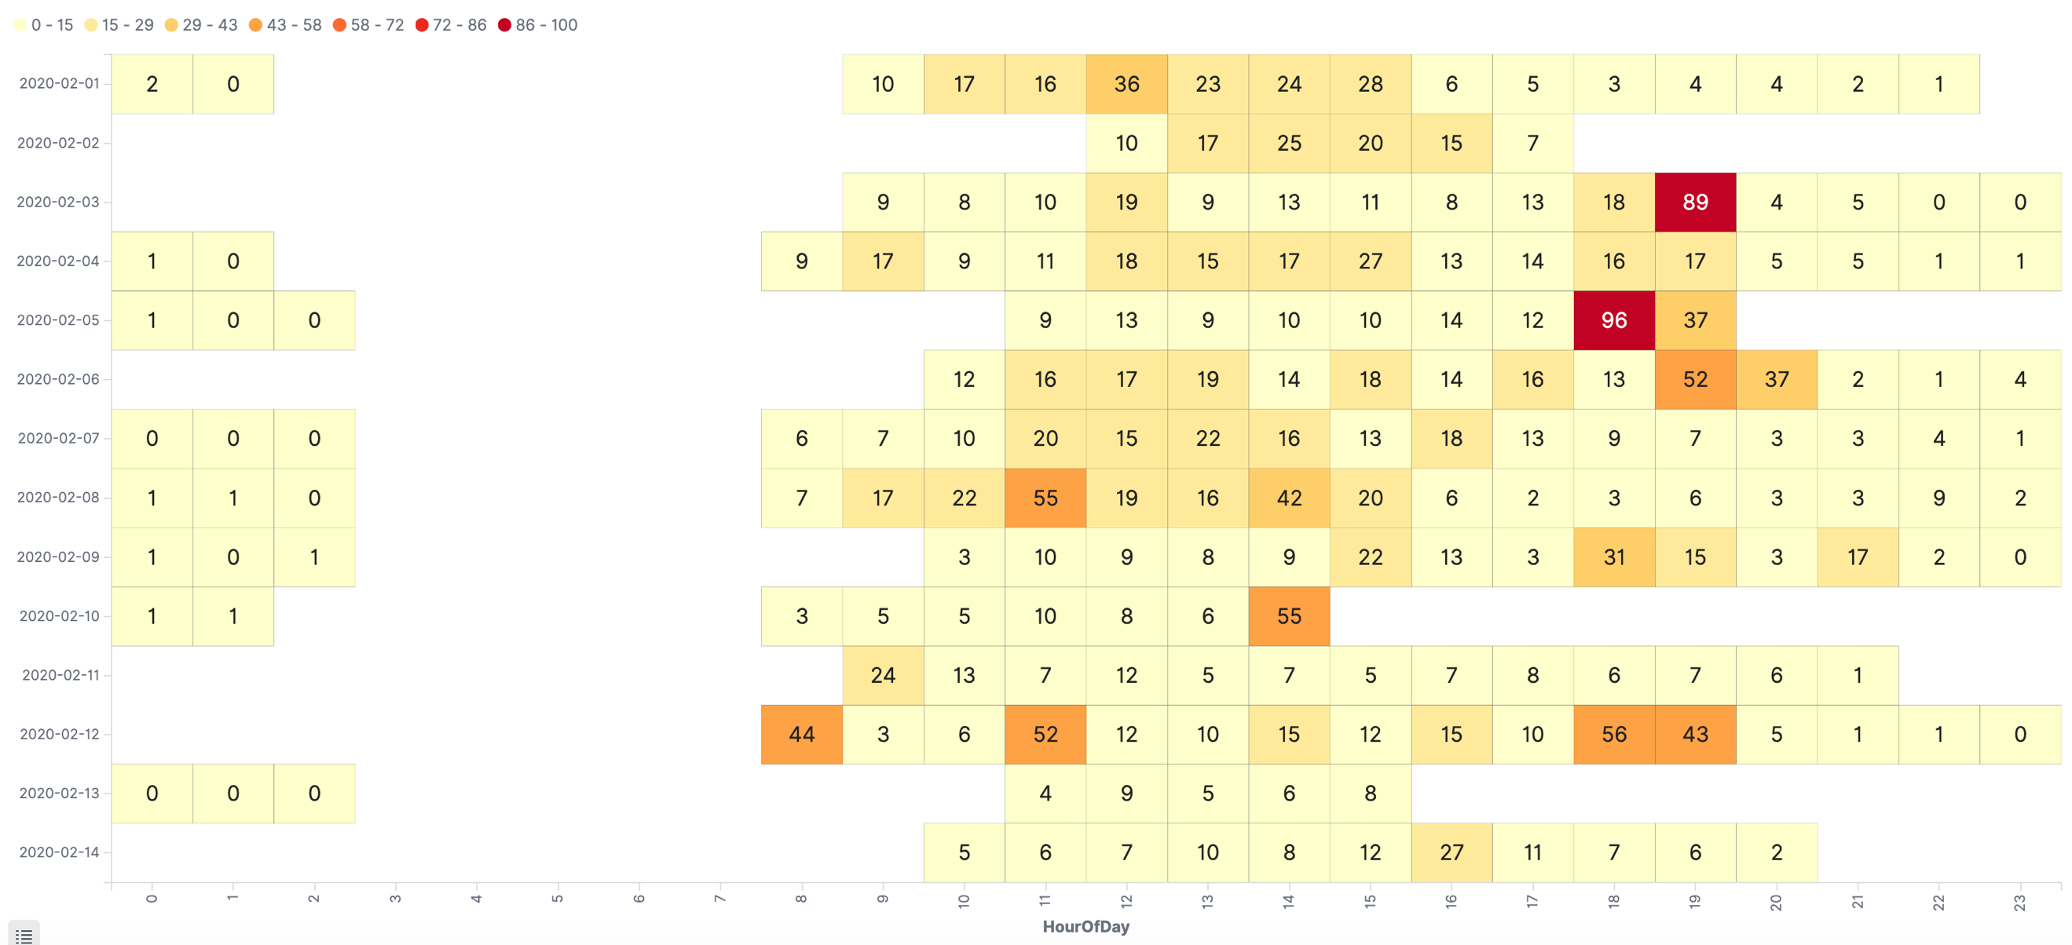

Inverleith Park is located north of the city next to the Royal Botanic Gardens, a large greenspace area with a number of park amenities and with a greater proportion of less kempt/wilder landscape and bordering hedging when compared to the Meadows. The park is much less of a through route. It is interesting to see the greater use of the park during the evening period 6pm-7pm, possibly due to people out jogging and dog walkers taking an evening stroll.

It should be noted the graph above does not display a full set of data due to some data communication issues arising from lack of battery power overnight, due to the much shorter daylight period each day during mid-winter in Scotland reducing the ability to restore charge to the battery from the solar panel. However, such “holes” do not invalidate the data that has been collected.

Meadows & Inverleith Family Area Activity

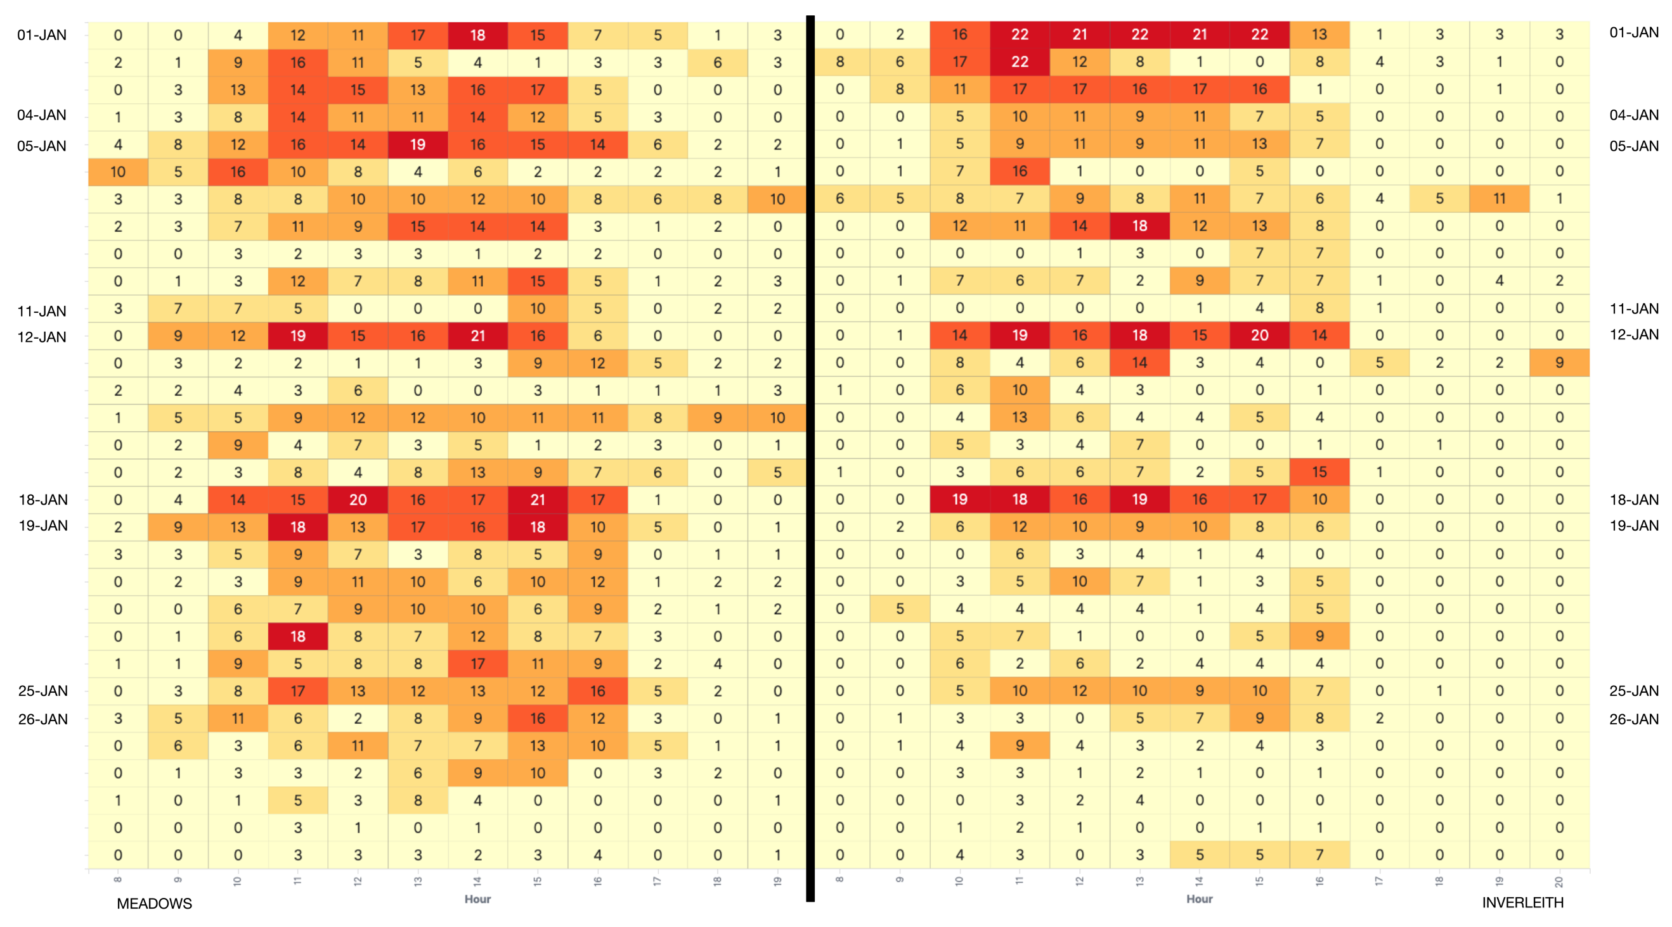

The two tables above show an activity heatmap for the Meadows (left) and Inverleith (right) parks across the whole of January 2020 with 1st January along the top row and 31st January along the bottom row; the hours from 8am to 8pm are from left to right in the graphs. These graphs are based on gate activity data that has been normalised to represent busyness that is comparable between the two parks.

The four weekend dates in January 2020 are 4/5, 11/12, 18/19, 25/26. The early period of January corresponds to the Scottish New Year holiday period and Edinburgh schools did not return till part way into the second week of January, so this was clearly a busy period in the family areas of both parks. What also shows clearly in the graph are the busy Sunday 12th and the following Saturday 18th and Sunday 19th dates across both parks. These days had little or no rainfall, compared to Saturday 11th which had approximately 20mm of rainfall and hardly any play park activity.

Bats in Meadows and Inverleith – 6 month period: September 2019 to February 2020

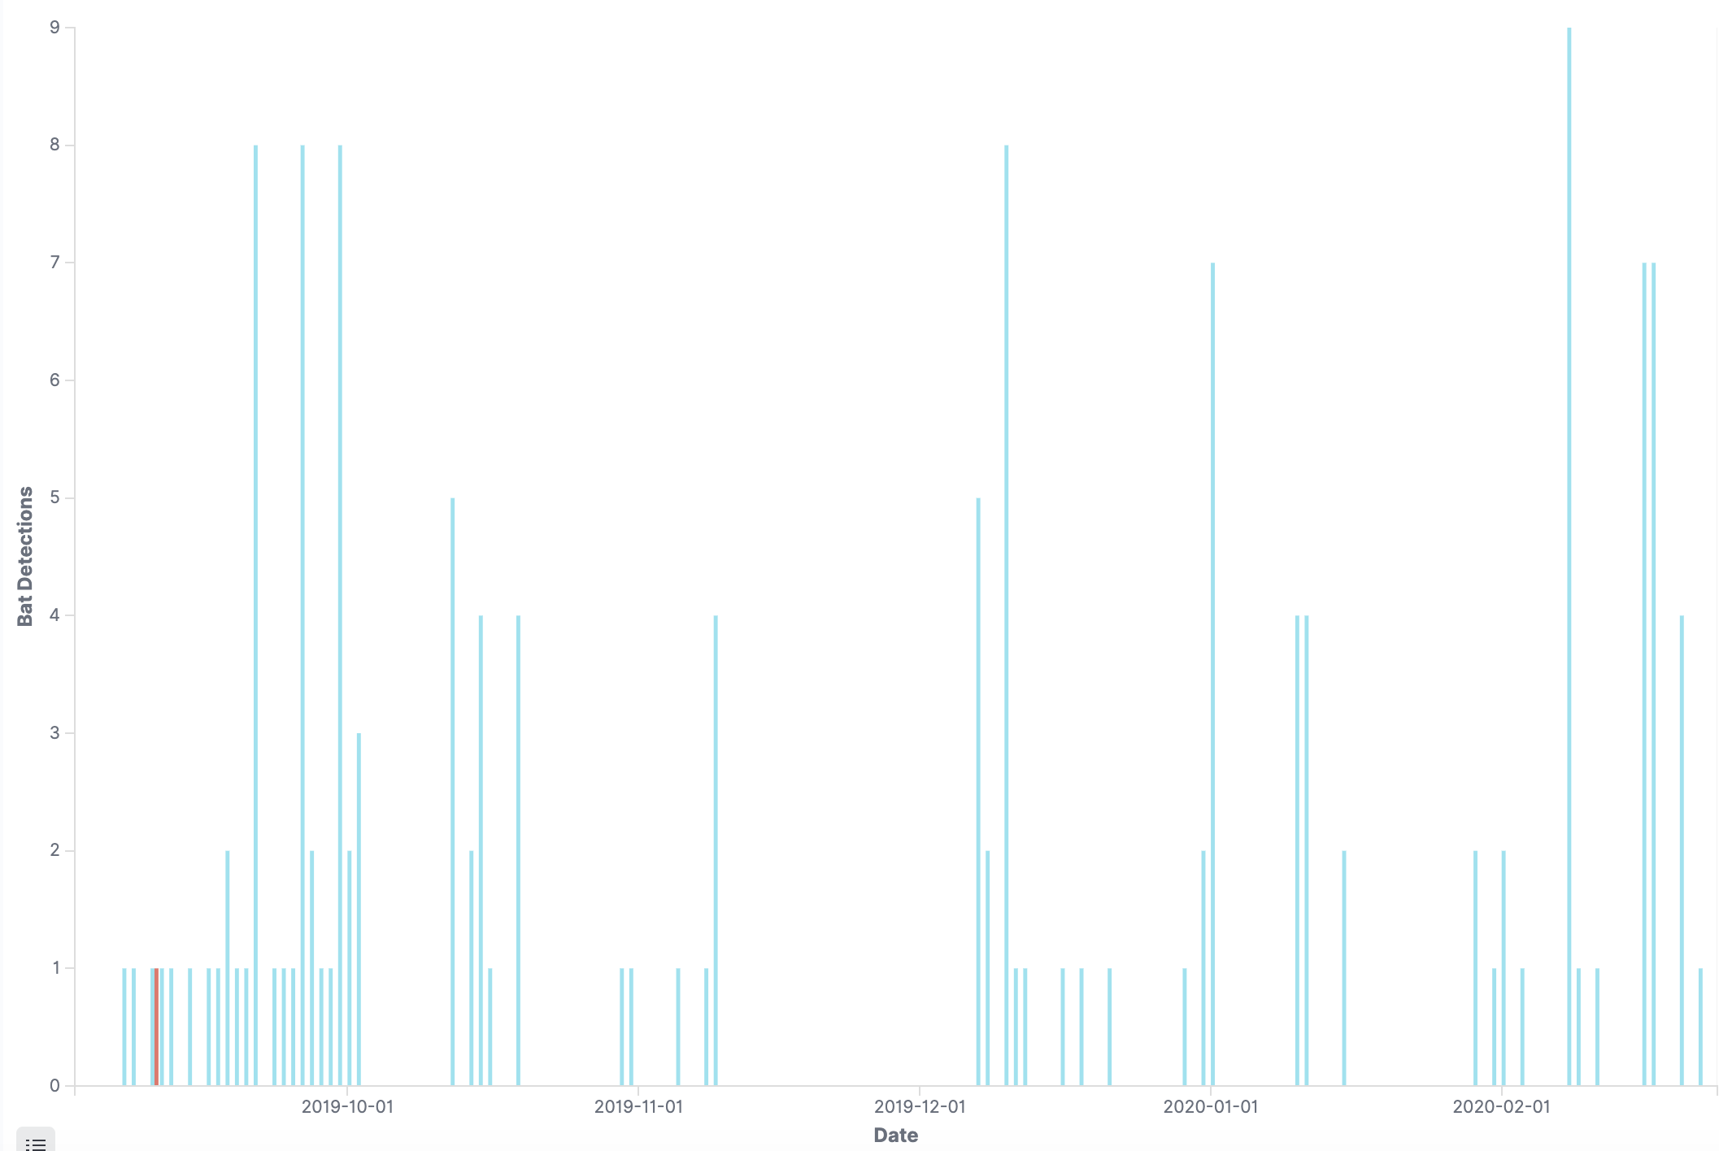

The barchart above depicts the number of bat detections from sunset to sunrise across the autumn and winter period of the project. Only a single bat detection was recorded in the Meadows (red), all other detections were made in Inverleith park (blue). Inverleith is a much more suitable habitat for bats than the Meadows, so this significant difference is not surprising.

It is interesting to note the rate of detection is highest during September with most nights triggering bat detections, and that there is a fallow period from November through December. This might be expected given the seasonal availability of insect prey for bats and the colder weather prompting bats to hibernate. However, we also see that bat activity is also present during the winter months at Inverleith perhaps reflecting the milder winter in general experienced over this timeframe in southern Scotland.